Divi All Purpose Child Theme

DIVI ALL PURPOSE CHILD THEME

Follow the instructions below to install and configure your new product

|  |  |
| --- | --- |
| **TABLE OF CONTENTS**   * [**A. Description**](https://support.aspengrovestudios.com/article/107-divi-all-purpose-child-theme#description) * [**B. Installing Divi All Purpose Child Theme on your Divi Site**](https://support.aspengrovestudios.com/article/107-divi-all-purpose-child-theme#installing) * [**C. Import Demo Data**](https://support.aspengrovestudios.com/article/107-divi-all-purpose-child-theme#import_demo_data) * [**D. Set Permalinks**](https://support.aspengrovestudios.com/article/107-divi-all-purpose-child-theme#permalinks) * [**E. Set Homepage and Posts Page**](https://support.aspengrovestudios.com/article/107-divi-all-purpose-child-theme#homepage) * [**F. Set Widget**](https://support.aspengrovestudios.com/article/107-divi-all-purpose-child-theme#widgets) | **THEME REQUIREMENTS**  **✓ Self-Hosted WordPress Installation  ✓ Divi Theme by Elegant Themes  ✓ Divi All Purpose Child Theme  ✓**[**PHP**](http://www.php.net/)**version 7 or greater ✓ memory\_limit 256M  ✓ post\_max\_size 128M  ✓ max\_execution\_time 180  ✓ upload\_max\_filesize 256M  ✓ max\_input\_time 600  ✓ max\_input\_vars 5000  ✓**[**MySQL**](https://www.mysql.com/)**version 5.6 or greater OR [MariaDB](https://mariadb.org/" \t "_blank)version 10.0 or greater.  ✓**[**HTTPS**](https://wordpress.org/news/2016/12/moving-toward-ssl/)**support  ✓**[**Nginx**](https://nginx.org/)**or**[**Apache**](https://httpd.apache.org/)**with mod\_rewrite module** |

***Remember:*** In order for the *Divi All Purpose child theme* to work, you must have **Divi** from Elegant Themes. If you do not have it you can purchase it [here](https://www.elegantthemes.com/affiliates/idevaffiliate.php?id=32248). Once you have it, please install it on your self-hosted WordPress website.

**A. DESCRIPTION**

A versatile child theme for Divi, Divi All Purpose can be used and reused multiple times to create an endless supply of websites. Catering to a span of industries, business types, brand identities and objectives, Divi All Purpose’s beautiful design and multi-functional form allow web designers to create unique and long-lasting web presences using one single child theme.

[\*\* Visit the Divi All Purpose Child Theme Page Here \*\*](https://aspengrovestudios.com/product/divi-all-purpose/)

**B. INSTALLING THE CHILD THEME**

Please upload the Divi All Child Theme to you your self-hosted WordPress website. Make sure the Divi theme is already installed and activated.

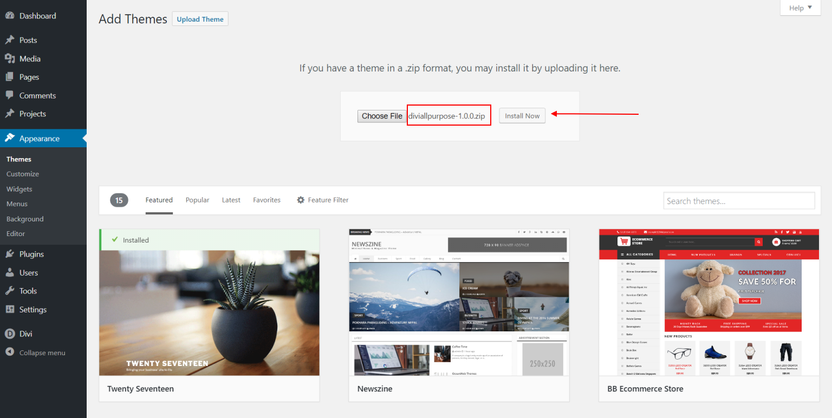

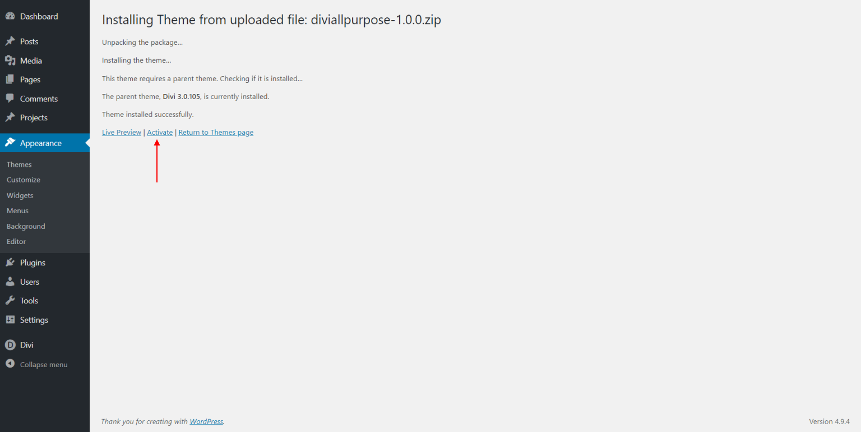

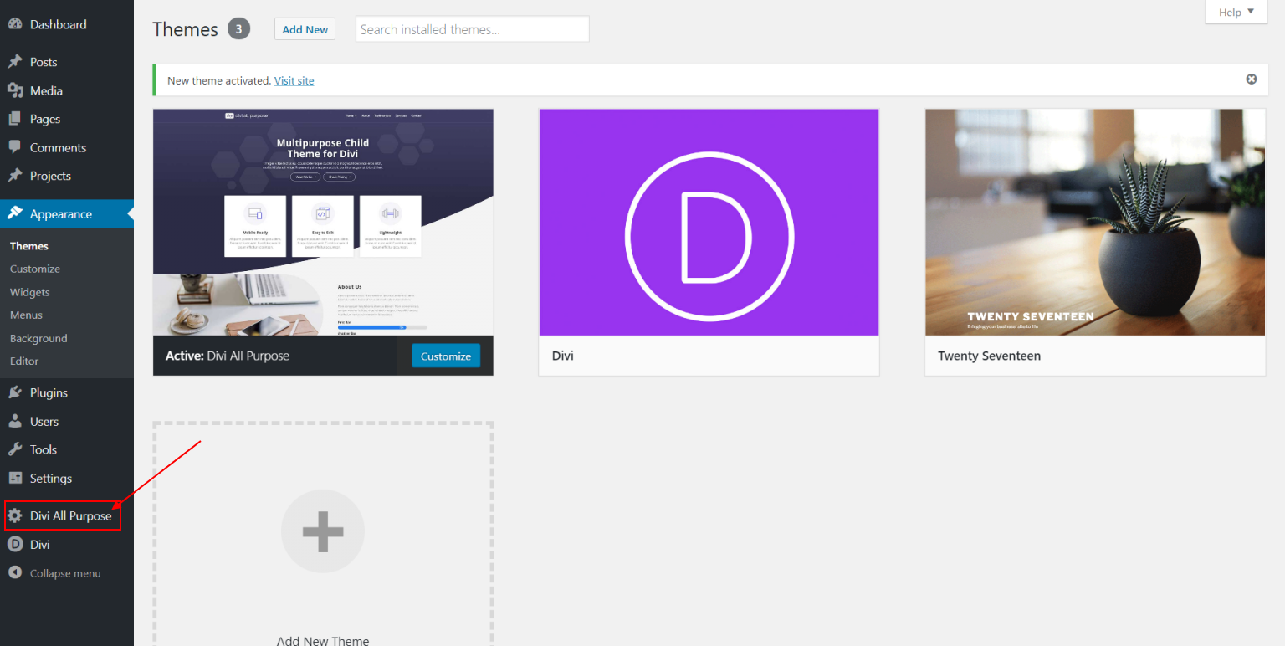

**B. IMPORT DEMO DATA**

From the WordPress Dashboard go to the newly added ‘Divi All Purpose’ tab on the left admin panel. Under the ‘Divi All Purpose’ menu, please click on ‘Import Demo Data’  **only once**. Please be patient while the demo data of the Divi All Purpose child theme is imported into your site.

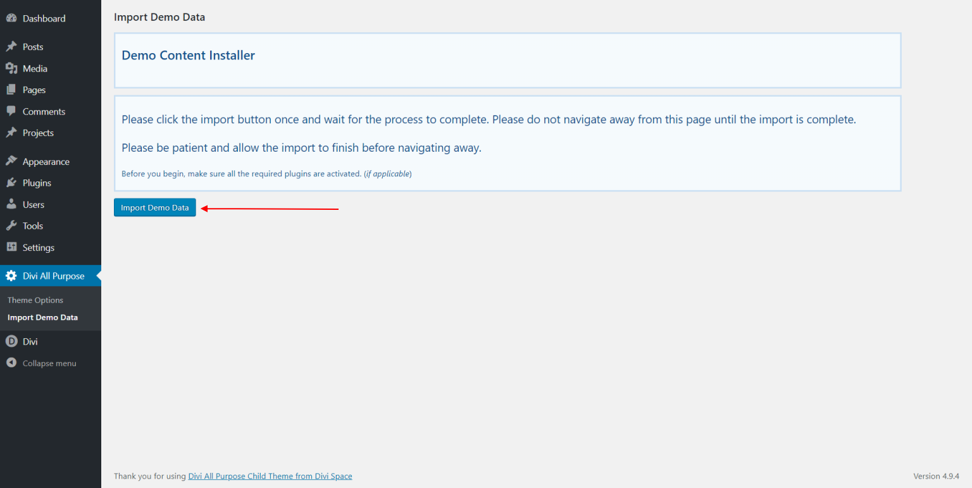

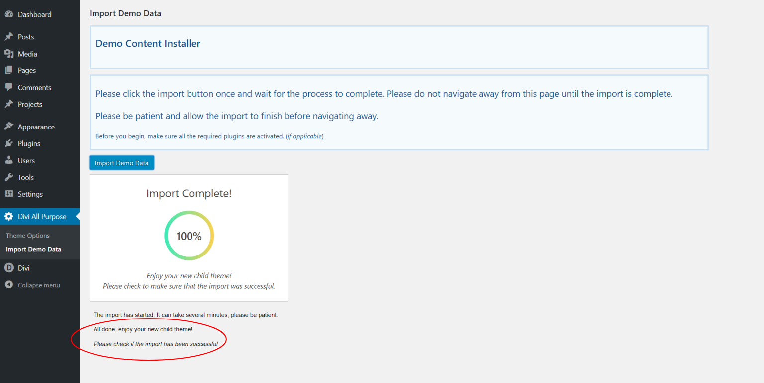

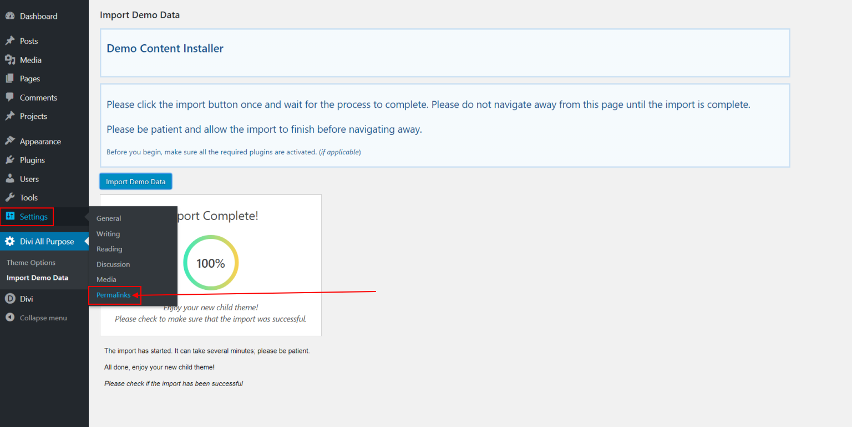

**C. SET PERMALINKS**

Go to the 'Settings' >> 'Permalinks' menu item in your admin sidebar and select "Post name" as your new permalinks choice.

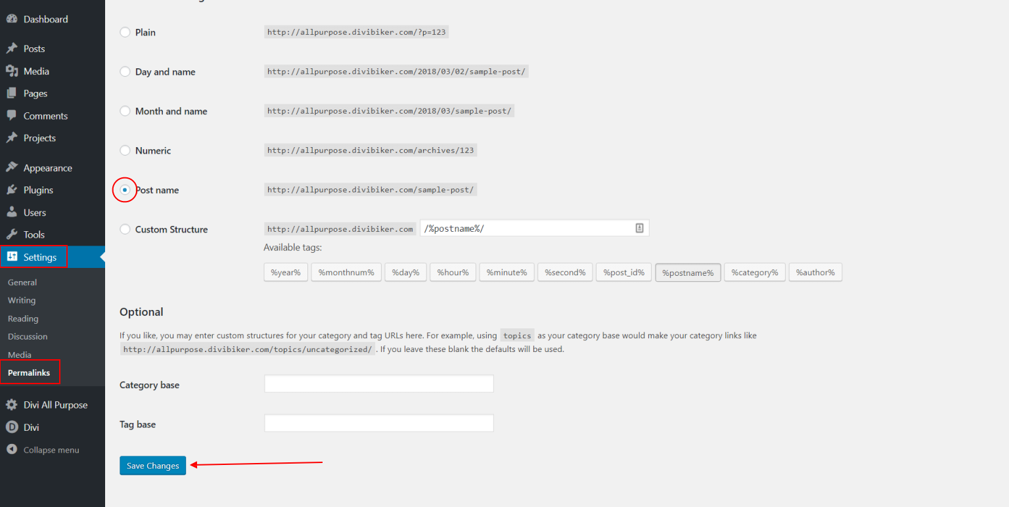

**D. SET HOMEPAGE AND POSTS PAGE**

Navigate to Settings >>Reading and choose 'A static page' for your homepage display, then click on the down arrow to drop down the options and select any of the homepage options given:

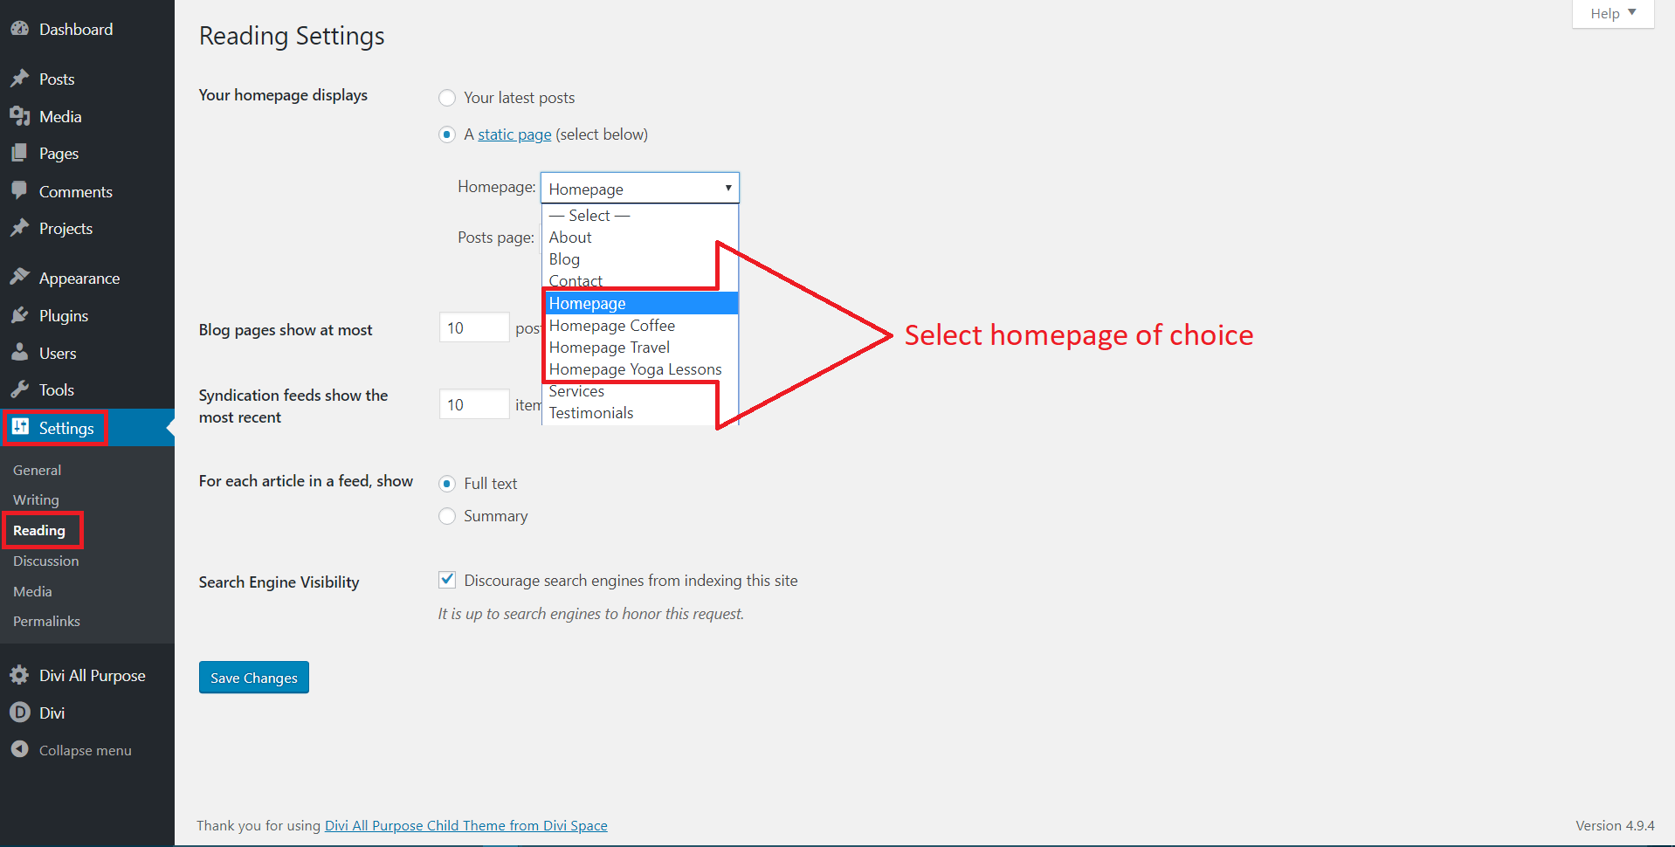

Next, select "Blog" to be your Posts Page. Save Changes.

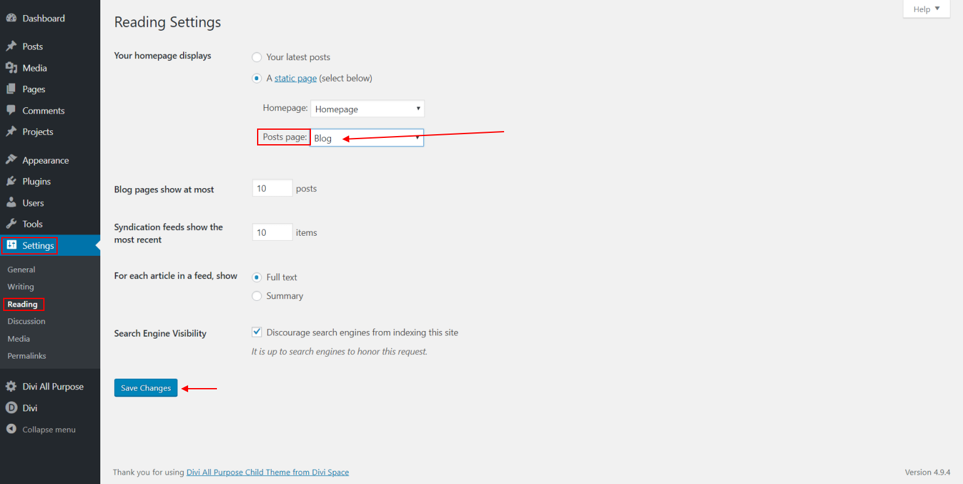

**E. SET WIDGETS**

Navigate to Appearance >> Widgets and make sure the widgets in the "Sidebar" are ordered as shown in the image and then select 'Footer Menu 2' for the "Footer Area #2" and 'Footer menu' for the "Footer Area #3"

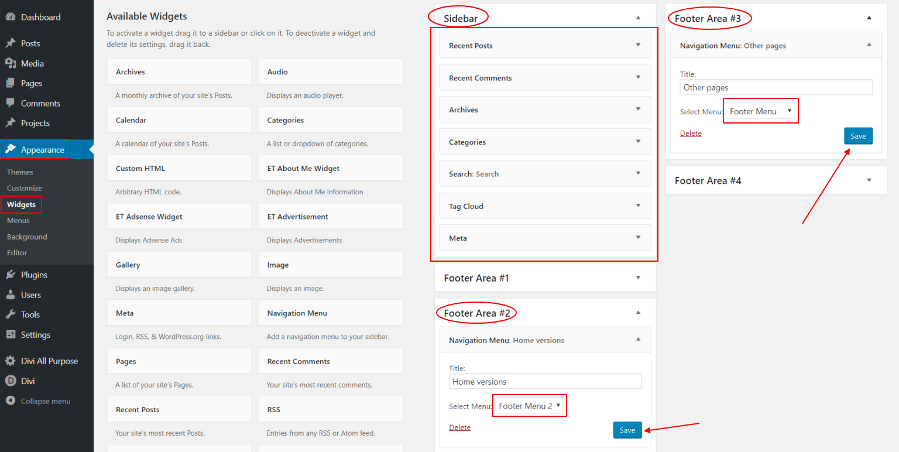

**NEED ADDITIONAL INFORMATION OR SUPPORT?**

For general WordPress information –  [wordpress.org](http://wordpress.org/)

For additional help with using Divi, Elegant Themes offers free technical support to all their members. –  [http://www.elegantthemes.com](https://www.elegantthemes.com/affiliates/idevaffiliate.php?id=32248)

**THANK YOU & ENJOY!**

*Still need help?*[*Contact Us*](https://support.aspengrovestudios.com/article/107-divi-all-purpose-child-theme#contactModal)

Last updated on August 22, 2018

**RELATED ARTICLES**

* [Divi eCommerce Child Theme](https://support.aspengrovestudios.com/article/96-divi-ecommerce-child-theme)
* [Divi Business Pro](https://support.aspengrovestudios.com/article/95-divi-business-pro)
* [Aspen Roots Child Theme](https://support.aspengrovestudios.com/article/11-aspen-roots-child-theme)